POS System: Development Plan by Feature
Oct 11, 2026 · @I want to create a time tracking system for a a estublishment th

Overview and scope
This plan builds a single-store restaurant and coffee-shop POS with a customer self-order kiosk, in 8 phases, one feature slice at a time. Version 1 covers menu, ordering, payments, kitchen display, shifts and reports, ingredient inventory, and the kiosk.
Who | What they do in the system
Super-admin | Developer or support account. Passes every permission check and is hidden from staff lists.
Owner | Runs the business: staff, settings, reports, inventory, credential resets.
Manager | Menu, approvals (void, discount, refund), inventory, shifts, reports.
Cashier | Takes orders and payments, opens and closes their own shift.
Barista or kitchen | Sees and bumps tickets on the kitchen display.
Kiosk customer | Orders on a kiosk. The kiosk is a registered device with a limited token, not a user.
Version 1 is done when a cashier or a kiosk customer can place an order, the bar or kitchen sees it, it is paid in cash or one e-wallet, a receipt is produced, ingredients are deducted, and the shift closes with a report.
Out of scope for version 1: multiple branches, delivery-app integrations, loyalty and vouchers, table-service floor plans, multi-language menus, and thermal printer drivers (browser printing comes first).

Stack and architecture decisions
Admin screens use plain Inertia; screens that update live use JSON endpoints with TanStack Query. That one rule decides where every new feature's code goes.
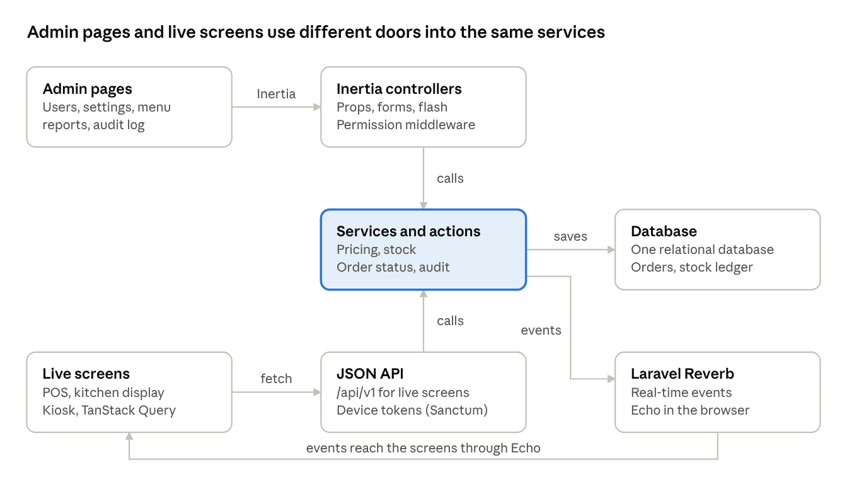
architecture · two doors, one service layer
Both doors call the same service classes, so pricing, stock and status rules exist once.
Layer | Choice | Notes
Backend | Laravel 13 | Controllers stay thin; business rules live in service or action classes.
Auth | Laravel Fortify, session based | Public registration is off; the owner creates staff accounts.
Roles and permissions | Spatie Laravel Permission | Roles are bundles of resource.action permissions.
Frontend | React 19, TypeScript, Inertia 3 | Pages live in resources/js/pages.
UI | Tailwind 4, shadcn/ui | Modal forms for small records, full pages for large ones.
Typed routes | Wayfinder | Run php artisan wayfinder:generate --with-form after route changes.
Live data | TanStack Query with the api() helper | POS, kitchen display and kiosk.
Local state | Zustand | The cart and the idle-lock timer.
Real-time | Laravel Reverb and Echo | Polling stays as a fallback.
Queue | Laravel queue (database first, Redis later) | Stock deduction, reports, notifications.
Devices | Laravel Sanctum tokens | Kiosks and kitchen screens authenticate as devices.
Tests | Pest | Feature tests per slice, unit tests for money and stock.

Which tool for which job
Job | Use | Controller returns
A form with fields (users, settings, menu items) | Inertia <Form> or useForm | back()->with('success', ...)
A one-click action (generate PIN, bump, toggle) | router.post or router.delete | back() with a flash
Live data without navigation (menu, orders, tickets) | TanStack Query with api() | JSON from /api/v1/...
Cart and idle timer | Zustand | Nothing; client only

Conventions every feature follows
These rules are fixed so each slice looks the same and money never drifts.
- Money is stored as integer centavos in columns ending in _cents (₱1.00 = 100). Never floats.
- Ids: normal tables use auto-increment ids. Orders and payments also carry a uuid for idempotency.
- Server-side pricing: the server recalculates every price. Prices sent by a client are ignored.
- Snapshots: order lines copy the product name, variant name, price and modifier prices at the time of sale, so menu edits never change history.
- Stock is a ledger: quantities change only by inserting stock_movements rows; stock_levels caches the sum.
- Idempotency: every create-order request carries an Idempotency-Key. A retry returns the first result instead of a duplicate.
- Permissions are named resource.action. The server enforces them with the permission: middleware; the UI only hides buttons with useCan() or <Can>.
- Messages: controllers return back()->with('success', ...). The global InertiaToasts listener shows success, validation and server errors as toasts.
- Soft deletes on menu and inventory master data. Money records are never deleted, only voided or refunded.
- Audit: sensitive actions (voids, refunds, discounts, price overrides, credential resets, role changes) write an audit_logs row.
- Super-admin is never assignable from the UI and is hidden from staff lists.
- Business date: a store day can run past midnight, so reports group by business_date, not by created_at.

Current status
The access-control foundation and the Users feature are built and working; settings, the audit log and PIN quick-login finish Phase 1.
Area | Status | Notes
Starter kit, Fortify login, Wayfinder | Done | Public registration disabled.
Roles and permissions (Spatie) | Done | PermissionSeeder, RoleSeeder, UserSeeder; super-admin bypass through Gate::before.
Permissions in React | Done | Shared through Inertia; useCan, <Can>, filtered sidebar, error page.
Users management | Done | List, search, modal create and edit, role guard, deactivate, PIN.
Generate new password or PIN | Done | Owner and super-admin only; shown once through a flash.
Active-user middleware | Done | Deactivated accounts are logged out.
Toasts for success and errors | Done | InertiaToasts listener with the kit's toaster.
Pest tests for access and users | Done | AccessControlTest, UserManagementTest.
Settings | To do | Phase 1.
Audit log | To do | Phase 1.
PIN quick-login | To do | Phase 1; the users.pin column already exists.
Menu, orders, kitchen, shifts, inventory, kiosk | To do | Phases 2 to 7.

Phase 1 remainder: settings, audit log, PIN quick-login
These three finish the foundation that every later feature depends on.

Settings
- Needs: table settings (key, value, group, type).
- Backend: SettingsService reads and writes settings and caches them; the cache is cleared on every update. Groups: Business (name, address, TIN, phone), Tax (default rate, inclusive or exclusive), Receipt (header, footer), Orders (pickup number prefix, business-day cut-off hour), Shifts (require an open shift), Kitchen (warning and late minutes).
- Frontend: one Inertia page settings/index with a card per group and one save per group.
- Permissions: setting.view, setting.update.
- Tests: a value saves and is cached; a cashier gets 403; an invalid tax rate is rejected.
- Done when: the owner changes the receipt footer and the new value is used everywhere without a deploy.

Audit log
- Needs: table audit_logs.
- Backend: an Auditable trait records created, updated and deleted events with old and new values, skipping hidden fields (password, pin). AuditLogger::record() covers custom events: login, credential reset, role change, void, refund. A scheduled job prunes rows older than 12 months.
- Frontend: page audit/index with filters for user, event and date, and a before and after view.
- Permissions: new audit.view for owner and super-admin.
- Tests: editing a user writes one row; the password never appears in a row; a manager gets 403.
- Done when: the owner can answer who changed something and when, for users and settings.

PIN quick-login
- Needs: users.pin (hashed, already built).
- Backend: POST /pin-login takes a user id and a PIN, checks Hash::check, and logs the user in. Throttle to 5 attempts per minute per user and IP, with a 5-minute lockout after 5 failures. Inactive users and users without a PIN are refused.
- Frontend: a lock screen that lists active staff, a numeric keypad, and a Zustand idle timer that returns to the lock screen after a set time.
- Permissions: none (public but throttled). It is restricted to registered POS devices in Phase 7.
- Tests: a correct PIN works; a wrong PIN fails; throttling locks out; a deactivated user is refused.
- Done when: a cashier switches accounts in under 5 seconds.

Phase 2: Menu management
The menu is the most important data in the system. The POS and the kiosk both read it, so it is built first and cached.
Feature | Backend | Frontend
Categories | CRUD, sort order, active flag | List page with modal create and edit, drag to reorder
Products | CRUD, category, base price, taxable flag, station override, sold-out flag | Product list with filters; full edit page with tabs
Variants (sizes) | Per-product variants with their own price and a default | Variants tab on the product page
Product images | Upload to the public disk, one primary image | Image uploader with preview
Modifier groups and modifiers | Single or multiple choice, required, min and max, price change, default, availability | Modifier groups page with modal forms
Attach modifier groups | Pivot with sort order | Modifiers tab on the product page
Sold-out toggle | One-click availability change, allowed for cashier and manager | Toggle on the product list and on the POS
Full menu endpoint | GET /api/v1/menu: one eager-loaded query, cached, cleared by model observers | Used by POS and kiosk through TanStack Query
Tables: categories, products, product_variants, product_images, modifier_groups, modifiers, product_modifier_groups.
Permissions: menu.view, menu.create, menu.update, menu.delete, plus new menu.availability.
Tests: the menu endpoint returns only active and available items; editing a product clears the cache; a modifier group cannot have min above max; a cashier can toggle sold out but cannot edit a price.
Done when: a full coffee menu with sizes and add-ons is entered through the UI and the menu endpoint returns it in one request. Seed a realistic DemoMenuSeeder so every later phase is tested against real complexity.

Phase 3: Ordering and payments
This is the core of the system. The server owns all pricing, and every order is created exactly once even when a request is retried.
Feature | Backend | Frontend
Order pricing | OrderPricingService prices lines from the database (variant price plus modifiers, times quantity), applies discounts and tax, and returns a full breakdown in centavos | Cart shows the server's totals
Create order | POST /api/v1/orders with an Idempotency-Key; one transaction writes the order, lines, modifiers, taxes and a status history row | POS submits the cart and shows the order number
Pickup numbers | order_number_sequences row is locked per business date to produce numbers like A-023 | Large number on the confirmation screen
Order lifecycle | OrderStatusService allows only valid transitions: open, confirmed, preparing, ready, completed, cancelled, voided | Status badges and filters
Discounts | Percent or fixed, per order or per line; senior and PWD discounts require an ID number and manager approval | Discount modal with ID capture
Payments | Cash with tendered amount and change; one e-wallet by reference number first; split payments; the order is paid when payments cover the total | Payment screen with quick cash buttons
Receipts | Sequential receipt number and a stored snapshot | Printable receipt preview
POS screen | Reads the cached menu | Category tabs, product grid, modifier picker, cart in Zustand with persistence, notes, order type, offline banner
Orders list | Today's orders with search | Inertia page with detail and reprint
Tables: orders, order_items, order_item_modifiers, order_status_history, order_discounts, order_taxes, order_number_sequences, payment_methods, payments, discounts, taxes, idempotency_keys, receipts.
Permissions: order.view, order.create, order.update, order.void, discount.apply, discount.manage, payment.take.
Tests: pricing unit tests for rounding, inclusive tax and stacked discounts; the same idempotency key twice creates one order; a client-sent price is ignored; pickup numbers stay unique under parallel requests; a cashier cannot void without approval.
Open item: the senior and PWD calculation (VAT exemption plus the 20% discount) must be confirmed with the store's accountant before launch.
Done when: a cashier takes an order with modifiers, accepts cash, sees the correct change, and the saved totals match the cart to the centavo.

Phase 4: Kitchen display and real-time
Orders reach the right station the moment they are confirmed, and the cashier sees when they are ready.
Feature | Backend | Frontend
Stations | Bar, kitchen, pastry; a product routes to its station override, otherwise to its category's station | Stations admin page
Ticket creation | On order confirmation, CreateKdsTickets splits lines by station into kds_tickets and kds_ticket_items | None
Kitchen display | JSON endpoint per station, device or staff auth | Full-screen ticket cards with timers that turn amber and red at the thresholds from settings, and a new-ticket sound
Bump and recall | Bump an item or a whole ticket; recall the last bump | Large touch buttons
Status roll-up | The order becomes ready when every ticket is bumped | Ready board on the cashier screen
Real-time | Reverb broadcasts new tickets and status changes on private channels; polling every 5 seconds as a fallback | Echo subscription in a hook that invalidates TanStack queries
Tables: stations, category_stations, kds_tickets, kds_ticket_items.
Setup: run php artisan install:broadcasting, configure Reverb, and authorize the private channels for staff and for kitchen devices.
Permissions: kds.view, kds.bump.
Tests: items split across two stations make two tickets; bumping the last ticket marks the order ready; a user without kds.view cannot join the channel.
Done when: an order with a drink and a pastry appears on the bar and pastry screens within a second, and bumping both marks it ready at the counter.

Phase 5: Shifts, receipts, reports
This phase closes the loop on daily cash handling and gives the owner the numbers. A first pilot in the store can start after it.
Feature | Backend | Frontend
Open shift | Opening cash count; payments require an open shift when the setting is on | Open-shift screen after login
Cash movements | Cash in, cash out, drops and payouts with a reason | Modal on the shift screen
Close shift | Counted cash against expected cash, with the variance stored | Close-shift screen with a denomination counter
Approvals | Manager PIN approval for void, refund, large discount and price override, recorded in discount_approvals | Approval modal
Refunds and voids | Partial or full refund capped at the amount paid; refund receipt | Refund flow from the order detail
X report | Mid-day snapshot that does not reset anything | One-click report
Z report | End-of-day close with a sequential number; locks the business date | Z report page with print
Reports | Daily sales; by item, category, hour, cashier and payment method; discounts, voids and refunds | Report pages with date filters and CSV export
Receipt printing | Browser print first; thermal ESC/POS later | Print stylesheet at 80 mm width
Tables: shifts, cash_movements, receipts, refunds, discount_approvals, z_reports, x_reports.
Permissions: shift.open, shift.close, shift.view-all, payment.refund, report.view, report.export.
Tests: expected cash equals opening cash plus cash payments plus cash in, minus cash out and cash refunds; a Z report total equals the sum of the day's paid orders; a refund cannot exceed its payment; a closed business date accepts no new orders.
Done when: the owner closes a day and the Z report matches the cash drawer and the e-wallet records.

Phase 6: Inventory, recipes, purchasing
Inventory hooks into paid orders, so it comes after ordering works. Stock is tracked per ingredient through a ledger.
Feature | Backend | Frontend
Units and conversions | Units with conversion factors (kg to g, bottle to ml) | Units admin
Ingredients | Categories, base unit, reorder level, average cost | Ingredient list and modal form
Recipes | One recipe per product or variant with ingredient quantities | Recipe editor on the product page
Modifier effects | A modifier can add, remove or replace an ingredient (oat milk instead of whole milk) | Modifier recipe tab
Stock ledger | Every change inserts a stock_movements row; stock_levels caches the sum | Movement history per ingredient
Automatic deduction | A queued DeductStockForOrder job runs when an order is paid; a unique reference prevents a second deduction | None
Stock counts | Count sessions that post variances as adjustments | Count screen
Waste | Waste log with a reason that posts a movement | Quick waste modal
Low-stock alerts | Notification when stock falls to the reorder level | Dashboard card and bell
Suppliers and purchase orders | Supplier prices and purchase orders with statuses | Supplier and purchase order pages
Goods receiving | Receipts against purchase orders update stock and average cost | Receive screen
Cost reports | Food cost percent, margin per product, usage and variance | Report pages
Tables: units, unit_conversions, ingredient_categories, ingredients, recipes, recipe_items, modifier_recipe_items, stock_levels, stock_movements, stock_counts, stock_count_items, waste_logs, suppliers, supplier_ingredients, purchase_orders, purchase_order_items, goods_receipts, goods_receipt_items.
Permissions: inventory.view, inventory.adjust, inventory.count, inventory.receive, plus new recipe.manage, supplier.manage, purchase.manage.
Tests: unit conversions are exact; a paid order deducts once even if the job runs twice; an oat-milk modifier removes whole milk and adds oat milk; stock may go negative but is flagged; receiving a delivery updates the average cost.
Done when: selling ten iced lattes lowers milk, beans and cups by the recipe amounts, and the low-stock alert fires at the reorder level.

Phase 7: Kiosk
The kiosk is another order channel on the same menu and order service, authenticated as a device with a limited token.
Feature | Backend | Frontend
Device registration | An admin creates a device and a one-time pairing code; the kiosk exchanges it for a Sanctum token with the abilities menu:read and orders:create | Devices admin page; pairing screen on the kiosk
Kiosk app | Same JSON endpoints under /api/v1, channel set to kiosk | Full-screen route with large touch targets and no keyboard
Ordering flow | Reuses OrderPricingService and idempotent order creation | Welcome, order type, categories, modifier modal, cart, confirmation
Upsell prompts | upsell_rules evaluated per cart | An add-a-pastry step before payment
Payment modes | Pay at counter creates an unpaid order and a pickup number; pay at kiosk uses an e-wallet QR | Mode comes from kiosk_settings
Idle reset | None | Zustand timer, warning countdown, clears the cart and returns to the welcome screen
Remote control | Out-of-service flag and sold-out items apply within about 15 seconds | Out-of-service screen; menu refetch interval
Heartbeats | The kiosk pings every 30 seconds; a scheduled job raises a notification after 2 missed minutes | Device status badges
Senior and PWD | The order is flagged until staff verify the ID at the counter | Prompt to see the cashier
Welcome screens | Promo banners with start and end dates | Rotating screen
Tables: devices, personal_access_tokens (Sanctum), kiosk_settings, kiosk_sessions, kiosk_heartbeats, kiosk_screens, upsell_rules.
Permissions: device.manage. The kiosk token never uses role permissions.
Tests: a kiosk token cannot call a staff route; a retried kiosk order is created once; unpaid kiosk orders expire after the configured time; an out-of-service kiosk refuses orders.
Done when: a customer builds an order on the kiosk, gets a pickup number, and the cashier pulls it up by number to take payment.

Phase 8: Hardening and launch
This phase proves the money paths, closes security gaps, and moves the store from the old method to the new system safely.
Area | Work
Money paths | Re-test totals, tax, discounts, refunds and rounding against hand-calculated cases
Concurrency | Parallel orders for pickup numbers and stock deduction
Permissions | List every route; each needs a permission or must be deliberately public; confirm a cashier cannot reach any manager endpoint
Security | HTTPS, secure session cookies, 2FA for owner and super-admin, rate limits on login, PIN and kiosk routes
Reliability | Daily database and file backups with a tested restore; supervised queue worker; scheduler running
Monitoring | Error tracking, log review, kiosk and printer offline alerts
Connection loss | Clear offline banner, retries that reuse the idempotency key, and a paper-ticket fallback plan
Performance | Check indexes and N+1 queries; warm the menu cache; test on the real tablet
Hardware | Test the receipt printer, cash drawer, tablet and kiosk screen in the store
Training | One-page guides for cashier, barista and manager
Pilot | Run alongside the old method for a few days and compare end-of-day totals
Go-live | Checklist, rollback plan and a named support contact for the first week

Permissions by feature
Every permission is named resource.action. Super-admin passes every check, so it is not a column. Permissions marked new must be added to PermissionSeeder and RoleSeeder in the phase that introduces them, followed by php artisan permission:cache-reset.
Permission | Phase | Owner | Manager | Cashier | Barista
menu.view | 2 | Yes | Yes | Yes | Yes
menu.create, menu.update, menu.delete | 2 | Yes | Yes | No | No
menu.availability (new) | 2 | Yes | Yes | Yes | No
order.view | 3 | Yes | Yes | Yes | Yes
order.create, order.update | 3 | Yes | Yes | Yes | No
order.void | 3 | Yes | Yes | No | No
discount.apply | 3 | Yes | Yes | Yes | No
discount.manage | 3 | Yes | Yes | No | No
payment.take | 3 | Yes | Yes | Yes | No
payment.refund | 5 | Yes | Yes | No | No
kds.view, kds.bump | 4 | Yes | Yes | No | Yes
shift.open, shift.close | 5 | Yes | Yes | Yes | No
shift.view-all | 5 | Yes | Yes | No | No
report.view, report.export | 5 | Yes | Yes | No | No
inventory.view, inventory.adjust, inventory.count, inventory.receive | 6 | Yes | Yes | No | No
recipe.manage, supplier.manage, purchase.manage (new) | 6 | Yes | Yes | No | No
device.manage | 7 | Yes | No | No | No
user.view | 1 | Yes | Yes | No | No
user.create, user.update, user.delete | 1 | Yes | No | No | No
user.reset-credentials (new) | 1 | Yes | No | No | No
role.manage | 1 | Yes | No | No | No
setting.view | 1 | Yes | Yes | No | No
setting.update | 1 | Yes | No | No | No
audit.view (new) | 1 | Yes | No | No | No

Testing strategy
Money and stock get the deepest tests, because a bug there costs real money or real inventory.
Layer | What it covers | Tool
Unit tests | Pricing, tax and discount rounding; unit conversions; stock deduction; status transitions | Pest
Feature tests | Every route: allowed role works, forbidden role gets 403, validation errors return the right messages | Pest with seeded roles
Concurrency tests | Pickup number generation and stock deduction under parallel requests | Pest with parallel processes
Idempotency tests | A retried order or payment creates one record | Pest
Frontend checks | TypeScript type check, lint and a production build before each merge | npm run build and the project's type and lint scripts
Browser tests | The cashier path from cart to paid order, and the kiosk path to a pickup number | Pest browser plugin, added in Phase 8
Test data: factories for every model, plus DemoMenuSeeder and DemoInventorySeeder with a realistic coffee menu, modifiers and recipes.
Merge gate: php artisan test, vendor/bin/pint --test and npm run build all pass. Target 100% coverage on OrderPricingService, OrderStatusService and the stock services.

Checklist for building any new feature slice
A slice is one feature built end to end, following the same twelve steps that Users used.
- Write the migration, model and factory.
- Add a form request with validation and clear messages.
- Write the controller with HasMiddleware permission checks; keep rules in a service class.
- Add the routes, then run php artisan wayfinder:generate --with-form.
- Build the Inertia page; use a modal form for small records and a full page for large ones.
- Add the sidebar item with its permission.
- Add new permissions to PermissionSeeder and RoleSeeder, then run php artisan permission:cache-reset.
- Return back()->with('success', ...) so the toast shows.
- Write an audit entry for sensitive actions.
- Write Pest tests: allowed role, forbidden role, validation, and the business rule.
- Add demo data to the seeders.
- Check on a tablet-sized screen, then update this plan's status table.
Definition of done: tests pass, the permission matrix is updated, the feature works for each role that should use it, and a forbidden role sees a clean 403.

Timeline and build order
The plan takes about 16 weeks for one developer, and a first pilot can start after Phase 5 with ingredient stock still counted by hand.
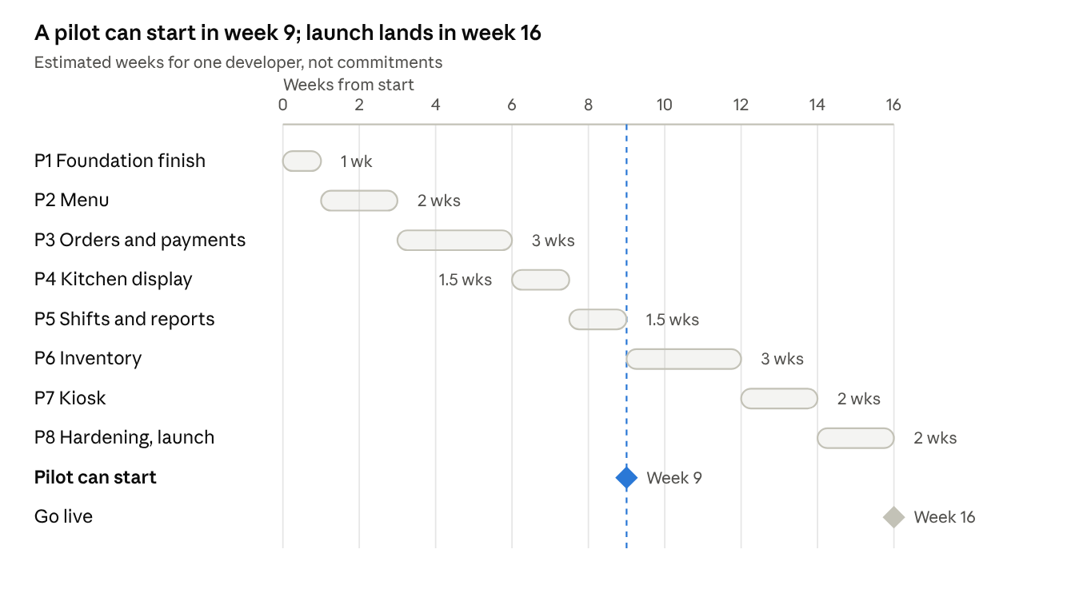
roadmap · 8 phases, 16 weeks, pilot in week 9
Build in this order because later phases read data that earlier ones create: menu before orders, orders before the kitchen display, and paid orders before stock deduction. Each phase ends with something demonstrable in the store.

Post-MVP backlog
These are deliberately left out of version 1. The schema for most of them is already drafted in the database doc.
- Combos and meal deals
- Time-based menus (breakfast, dinner) and channel-only menus
- Table service: floor plan, merge and split tables, transfer orders
- Customers, loyalty points and vouchers
- Multi-language menu text
- Online ordering and delivery-app integrations
- Thermal receipt printing, cash drawer and barcode scanner drivers
- Offline queueing so orders survive a lost connection
- Tips distribution reports and staff scheduling
- Accounting export and e-invoicing
- A second branch (adds a store key to the tables that need it)

